MD2201: Data Science

Name of the student: Nisha Modani Roll No. 66

Div: CS_B Batch:B3

Date of performance: 30-09-20

Experiment No.2

Title: Laboratory on Statistics
Aim: To find the probability for Binomial distribution and Normal distribution and verify the Normal approximation of Binomial distribution.

Software used: Programming language R.

Code Statement:
Write a single R code to answer the following questions.

Data Set: Travelled Abroad

- Find out the % of Indians in the sample who have travelled abroad using the data source.
- Treating this value as ‘p’, calculate the following probabilities –
  - What is the probability that in a randomly chosen sample of 10 persons, no one has travelled abroad.
  - What is the probability that in a randomly chosen sample of 10 persons, exactly one has travelled abroad.
  - What is the probability that in a randomly chosen sample of 10 persons, exactly two persons have travelled abroad.
  - What is the probability that in a randomly chosen sample of 10 persons, exactly three persons have travelled abroad.
  - What is the probability that in a randomly chosen sample of 10 persons, exactly four persons have travelled abroad.
  - What is the probability that in a randomly chosen sample of 10 persons, exactly five persons have travelled abroad.
  - What is the probability that in a randomly chosen sample of 10 persons, exactly six persons have travelled abroad.
  - What is the probability that in a randomly chosen sample of 10 persons, exactly seven persons have travelled abroad.
  - What is the probability that in a randomly chosen sample of 10 persons, exactly eight persons have travelled abroad.
  - What is the probability that in a randomly chosen sample of 10 persons, exactly nine persons have travelled abroad.
  - What is the probability that in a randomly chosen sample of 10 persons, all 10 persons have travelled abroad.
- Plot the probability values as a Table / Bar graph/plot and interpret plot.
- What is the probability that in the randomly chosen sample of 100 persons at least 59 have travelled abroad?
Hint: Expected to perform Normal approximation for the binary distribution.

Code: (Write code here)
setwd("C:/Users/HP/Desktop/Data science/Data sets")

d<-read.csv("travelled abroad data_csv.csv",header=T)
#1 percentage and probaility
p<-sum(d$Travelledabroad=="Y")/nrow(d)
percentage<-p*100
cat("\npercentage of people who travelled abroad: ",percentage)

#2 probabilities for n=10 from 0 to 10
b<-dbinom(0:10,10,p)
cat("\nprobailities for n=10: ",b)

#3 plotting
x<-seq(0,10,by=1)
y<-dbinom(0:10,10,p)
plot(x,y,type = "l", main = "for n=10")

x<-seq(0,100,by=1)
y<-dbinom(x,100,p)
plot(x,y,type = "l",main="n=100")

#5 probaility with binomial and normal distribution
mean<-100*p
cat("\nmean of data: ",mean)
sd<-sqrt(100*p*(1-p))
cat("\nstandard deviation of data: ",sd)

b1<-sum(dbinom(59:nrow(d),100,p))
cat("\nprobability for n atleast 59 in binomial distribution: ",b1)

n<-pnorm(59,mean,sd,lower.tail = F)
cat("\nprobability for n atleast 59 in normal distribution: ",b1)

Results: Display the output obtained on R console for all the cases. Also add the plots which you obtained. Give proper title to the plots as per the condition.

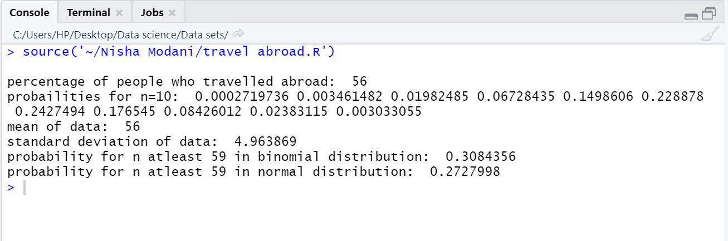

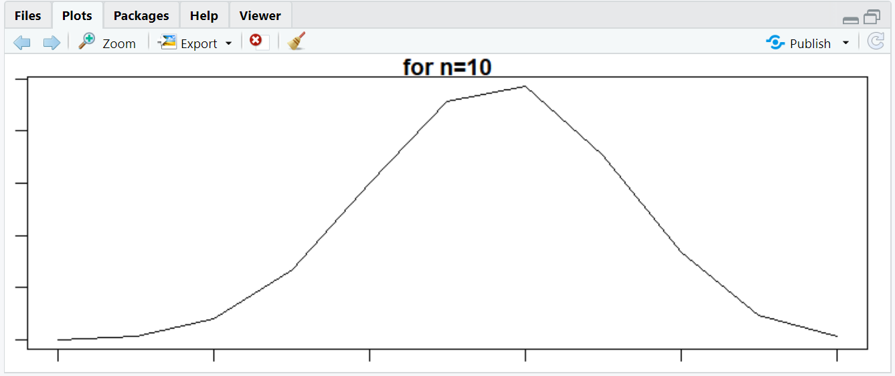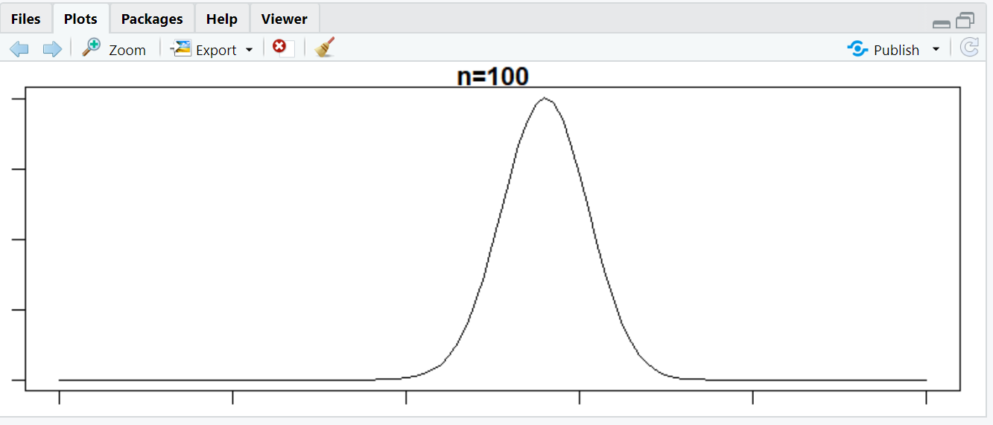

Conclusion: (Write the conclusion in your words)

From this experiment I have learnt about binomial distribution.

Learnt to find probability for binomial distribution also learnt to plot normal distribution curves.

Learnt to use functions like dbinom, pnorm, dnorm, etc.

From curves it is clear that as no. of samples increase binomial distribution curve approach normal distribution

